

Practices for Secure Software Report

Table of Contents
Document Revision History 3
Client 3
Instructions 3
Developer 4
1. Algorithm Cipher 4
2. Certificate Generation 4
3. Deploy Cipher 4
4. Secure Communications 4
5. Secondary Testing 4
6. Functional Testing 4
7. Summary 4
8. Industry Standard Best Practices 4

Document Revision History

Version | Date | Author | Comments
1.0 | Mar.2,2026 | Brayan Tellez

Client



Instructions

Submit this completed practices for secure software report. Replace the bracketed text with the relevant information. You must document your process for writing secure communications and refactoring code that complies with software security testing protocols.

- Respond to the steps outlined below and include your findings.
- Respond using your own words. You may also choose to include images or supporting materials. If you include them, make certain to insert them in all the relevant locations in the document.
- Refer to the Project Two Guidelines and Rubric for more detailed instructions about each section of the template.

Developer
Brayan Tellez

Algorithm Cipher
For this project, I implemented a cryptographic hashing algorithm to ensure data integrity and demonstrate secure handling of information. Hashing plays an important role in software security because it allows data to be verified without exposing the original value. Instead of encrypting data so it can later be decrypted, hashing creates a one-way transformation that produces a unique output for a given input.

The algorithm used in this project was SHA-256. This algorithm was chosen because it is a widely accepted industry standard and is commonly used in real-world applications such as digital signatures, password storage, and integrity verification. SHA-256 generates a fixed-length hash value, which makes it easy to compare results and detect even the smallest change in data. If the input changes by even one character, the resulting hash is completely different.

Using SHA-256 in this application allowed me to generate checksums that verify whether data has been altered during processing or transmission. This supports secure design principles by ensuring accuracy, integrity, and trust in the data being handled. Implementing this hashing algorithm helped reinforce the importance of protecting sensitive information while still allowing verification when needed.

Certificate Generation
Insert a screenshot below of the CER file.

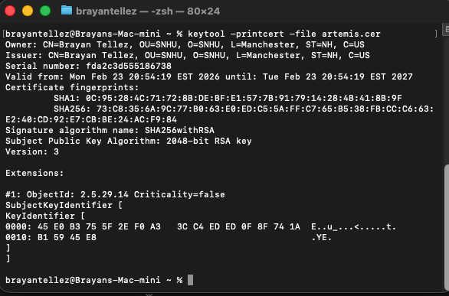

Deploy Cipher

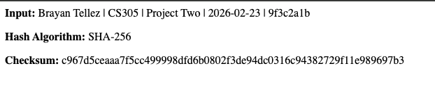

Secure Communications
Insert a screenshot below of the web browser that shows a secure webpage.

Secondary Testing
Insert screenshots below of the refactored code executed without errors and the dependency-check report.
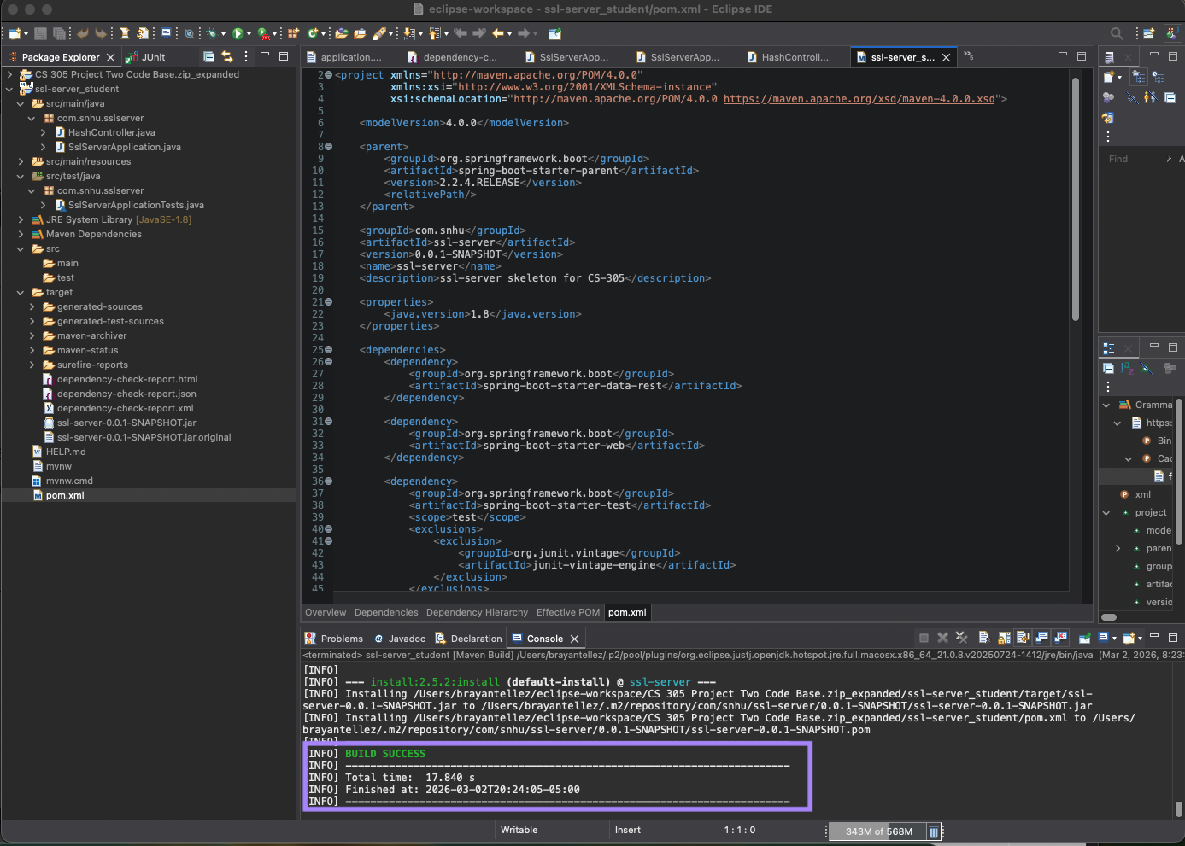

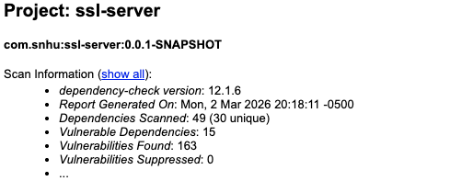

Functional Testing
Insert a screenshot below of the refactored code executed without errors.
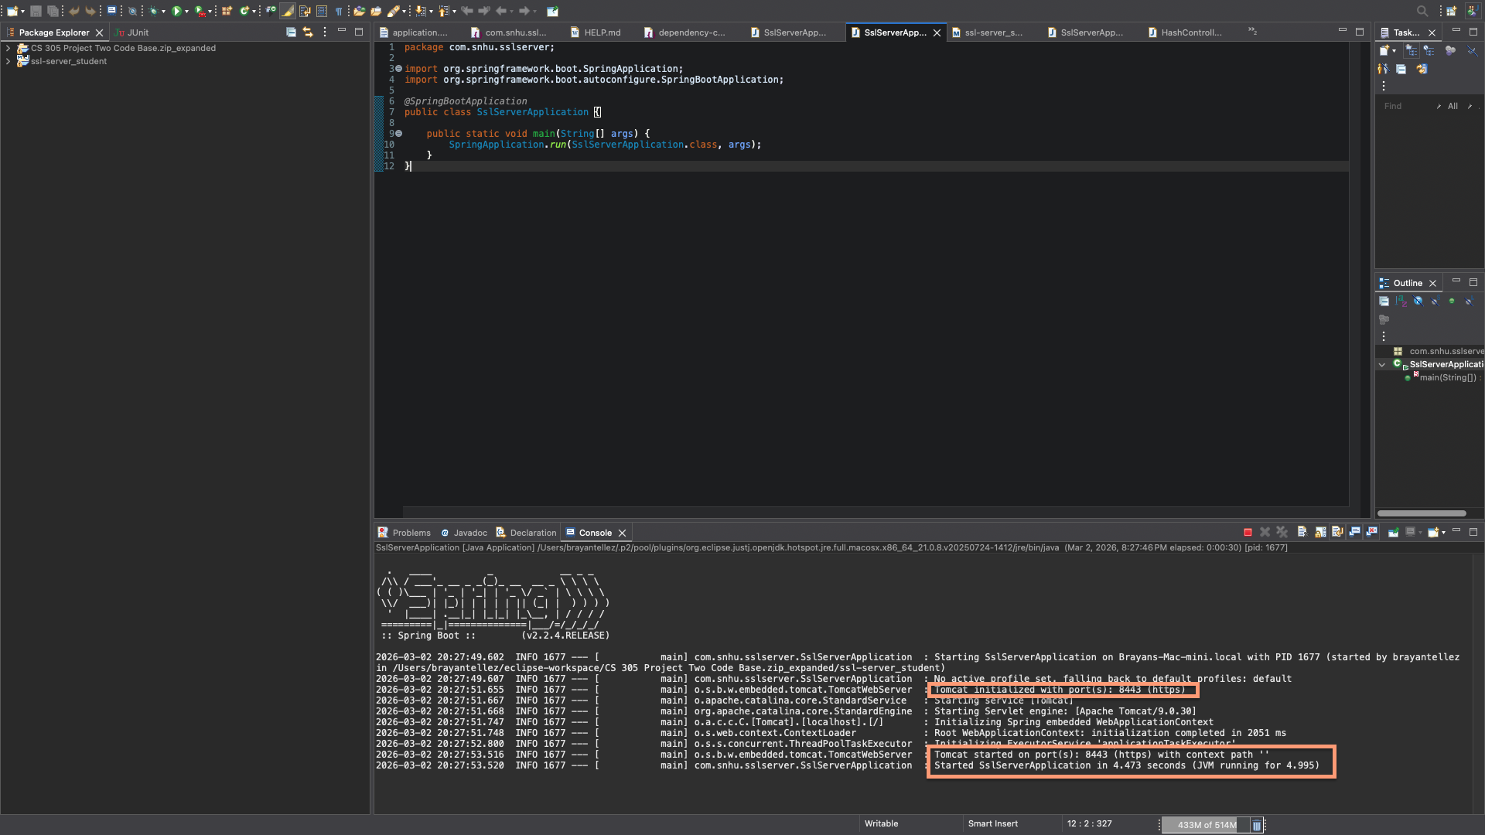
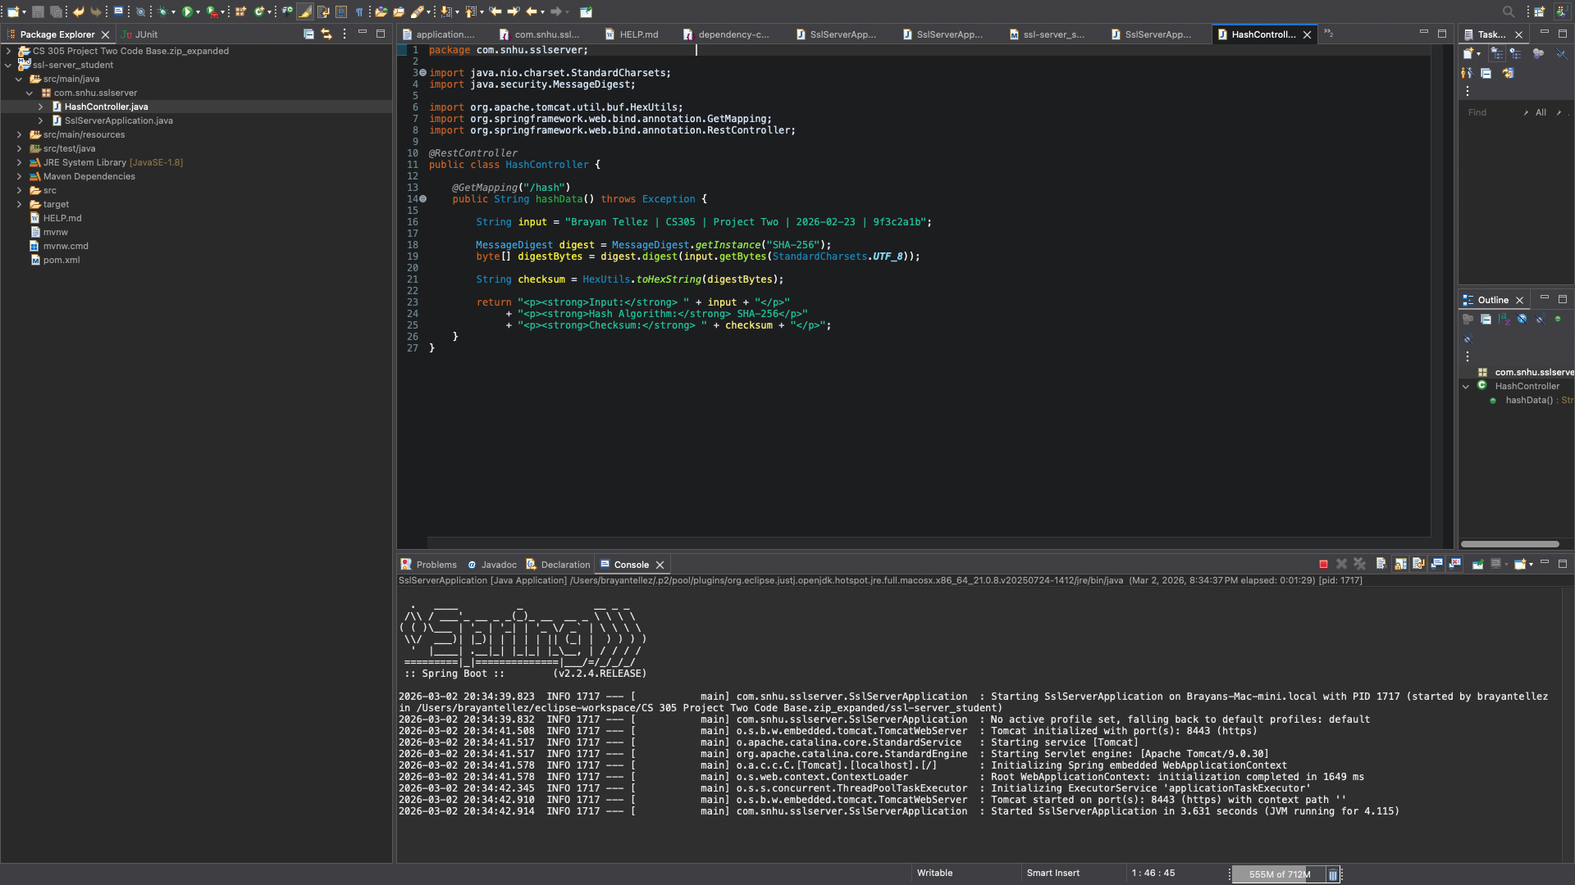

Summary
This project served as a comprehensive demonstration of the security concepts covered throughout the course. It required applying multiple techniques rather than focusing on a single aspect of security. By combining hashing, certificate generation, secure communication, and vulnerability scanning, the project showed how secure software development is built through layers of protection.

Working through each step highlighted how security decisions impact the overall reliability of an application. Generating checksums reinforced the importance of data integrity, while configuring HTTPS emphasized the need to protect information during transmission. Running vulnerability scans also demonstrated how third-party dependencies can introduce risks, even when the application code itself appears secure.

Overall, this project strengthened my understanding of how security is integrated into real applications. Instead of treating security as a separate task, the project showed how it must be considered during development, testing, and deployment. Completing this project increased my confidence in implementing secure practices and evaluating software from a security perspective.

Industry Standard Best Practices

Industry-standard best practices were followed throughout this project to align the application with modern security expectations. One of the most important practices was the use of a trusted cryptographic hashing algorithm. By selecting SHA-256, the application relies on a hashing method that is both widely accepted and resistant to known attacks.

Secure communication was another key best practice addressed in this project. HTTPS was configured using SSL/TLS to protect data in transit and prevent unauthorized interception. This ensures that users interacting with the application can trust that their information is transmitted securely, even when using a self-signed certificate in a development environment.

Additionally, automated security testing was performed using the OWASP Dependency-Check tool. This practice is essential in modern software development because applications often depend on third-party libraries that may contain vulnerabilities. Running dependency scans helps identify potential risks early and encourages developers to keep dependencies up to date or apply mitigations when necessary.

By following these best practices, the project demonstrates a proactive approach to secure software development. These techniques are commonly used in professional environments and provide a strong foundation for building applications that prioritize security, reliability, and maintainability.

